NAME:NAVODITAA A.R
ROLL NO.:241901071

Exercise 11

CUSTOMISE SWITCH WITH NETWORK MODULES USING CISCO PACKET TRACER
Aim:
To customize a switch by adding network modules in Cisco Packet Tracer and verify extended connectivity options.
Introduction:
In Cisco devices, network modules are removable or pluggable components that expand the functionality of switches or routers.
By adding modules, we can:
- Increase the number of Ethernet ports.
- Add fiber optic (Gigabit) or FastEthernet interfaces.
- Support new technologies like wireless or WAN connections.
Cisco Packet Tracer allows us to virtually add or remove these modules to simulate real-world hardware customization.
Algorithm:
1.Start Packet Tracer and place a Router 2811 on the workspace.
2. Power off the router (Physical tab).
3.Remove cover plates from empty module slots.
4.Insert network modules (e.g., NM-1T, NM-1E) into empty slots.
5.Power on the router.
6.Check new interfaces appear (FastEthernet, Serial, Ethernet).
7.Place PCs (PC0, PC1) near the router.
8.Connect PCs to router interfaces using Copper Straight-Through cables.
9.Configure router interfaces:
- Assign IP address
- Enable interface (no shutdown)
10.Configure PCs:
- Assign IP address in same subnet
- Set default gateway as router interface IP
11. Test connectivity:
- Ping router from PCs
- Ping PC1 from PC0 and vice versa

Topology:

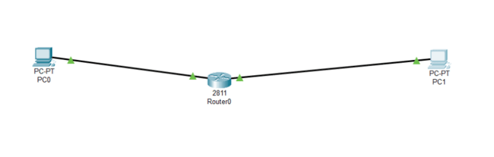

Output:
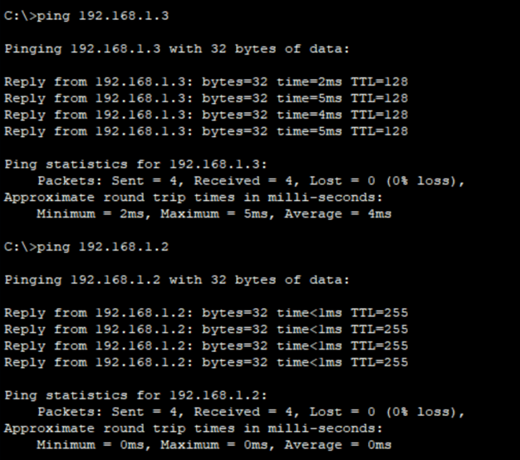

Result:
The switch was successfully customized by adding a network module, and the newly added ports functioned correctly for connecting PCs in Cisco Packet Tracer.

